

**KENYA CERTIFICATE OF SECONDARY EDUCATION**

**451/3 COMPUTER STUDIES PROJECT DOCUMENTATION**

**NEKTA MANAGEMENT SYSTEM**

NAME OF THE SCHOOL:

STUDENT NAME:

INDEX NUMBER:

YEAR: 2022

# DECLARATION

I hereby declare that all the information included in this document is my original work and was not copied from any other source. All information from other sources have been properly cited. I also declare that I worked on this project to the best of my knowledge and followed the project guideline and structure that was provided by the Kenya National Examination Council.

STUDENT’S NAME: ……….……………… SIGNATURE……..… DATE: …………

SUPERVISOR’S NAME ………………………SIGNATURE………DATE………….

# ACKNOWLEDGEMENT

I would like to thank my classmates for the cooperation and assistance they provided me as I was working on this project. I will forever be grateful for everything they did to me and for giving me a conducive environment to work on this project. I would also like to thank my computer studies teacher, **<<insert the name of your computer studies teacher>>** for the guidance and supervision as I was handling the project. Thank you very much and may God always bring good things unto your ways. Lastly, thank you Almighty God for the gift of life and for giving me strength and wisdom to work on this project.

# Table of Contents

DECLARATION 2

ACKNOWLEDGEMENT 3

Table of Contents 4

INTRODUCTION 10

Chapter 2: System Analysis 11

Problem Recognition and Definition 11

Analysis of the existing system 12

Overview of the existing system 12

Weaknesses of the existing system 13

Analysis of the proposed system 14

Overview of the proposed system 14

Objectives of the proposed system 15

**General Objective** 15

**Specific objectives** 15

Benefits of the proposed system 15

Feasibility Study 16

Technical Feasibility 16

Schedule Feasibility 16

Economic Feasibility 17

Chapter 3: System Design 20

System Flowchart 20

File Structures Design 22

i. Drivers Details 22

ii. Loaders Details 22

iii. Members Details 22

iv. Group Members Details 23

v. Vehicles Details 23

vi. Good Transported 23

Input Design 24

i. Large scale farmers’ registration form 24

ii. Group farmers’ registration form 25

iii. Vehicle expenses recording form 26

iv. Transport order recording form 27

v. Driver offenses recording form 28

Output Design 29

i. Company expenses report 29

ii. Drivers monthly penalties report 30

iii. Goods Transported Report 30

iv. Vehicle Expenses Report 31

Chapter 4: System Construction 32

Tables 32

i) Membership table 32

ii) Small scale Farmers table 32

iii) Transport orders table 33

iv) Vehicle expenses table 33

v) Drivers table 34

Relationships 35

Input Screens 36

i) Groups registration form 36

ii) Large scale farmers’ registration form 37

iii) Transport order placing form 37

iv) Vehicle expenses Recording form 38

Data Manipulations 39

i) Payments to loaders query 39

ii) Payments to drivers’ query 40

iii) Penalties surcharged on drivers’ query 41

iv) Revenue per vehicle query 42

v) Expenses for each vehicle 43

vi) Tax payable 44

vii) Overall company expenses query design 45

viii) Overall company profit calculation 46

Output Screens 47

i) Transport Order invoice report 47

ii) Company Revenue Report 48

Chapter 5: User Manual 50

Introduction 50

Installing the system 50

Loading Nekta Management System 51

Guide on navigating through the system 54

Guide on generating a report from the system 55

Chapter 6: Miscellaneous 61

Conclusion 61

Recommendations 61

References 62

Appendix 63

Figure 1: Monthly cost of running the current system 17

Figure 2: System Flowchart 20

Figure 3: Drivers details file design 22

Figure 4: Loaders details file design 22

Figure 5: Members details file design 22

Figure 6: Group members details file design 23

Figure 7: Vehicles details file design 23

Figure 8: Goods transported file design 23

Figure 9: Large scale farmers registration form design 24

Figure 10: Group farmers registration form 25

Figure 11: Vehicle expenses recording form 26

Figure 12: Transport orders recording form 27

Figure 13: Driver offenses recording form 28

Figure 14: Company expenses report design 29

Figure 15:Drivers monthly penalties report design 30

Figure 16: Goods transported report design 30

Figure 17: Vehicle expenses report design 31

Figure 18: Membership table 32

Figure 19: Small scale farmers table 32

Figure 20: Transport orders table 33

Figure 21: Vehicle expenses table 33

Figure 22: Drivers table 34

Figure 23: Relationships 35

Figure 24: Groups registration form 36

Figure 25: Large scale farmers registration form 37

Figure 26: Transport order placing form 37

Figure 27: Vehicle expenses recording form 38

Figure 28: Payment to loaders query design 39

Figure 29: Payments to drivers query design 40

Figure 30: Penalties on drivers query design 41

Figure 31: Revenue per vehicle query design 42

Figure 32: Expenses for each vehicle query design 43

Figure 33: Tax payable query design 44

Figure 34: Company expenses query design 45

Figure 35: Company profit query design 46

Figure 36: Transport order invoice 47

Figure 37: Company revenue report 48

Figure 38: Driver penalties report 49

Figure 39: Installing the system 51

Figure 40: Nekta Management System Log in Screen 52

Figure 41: Successful Login Screen 53

Figure 42: Nekta Management System Main Switchboard 54

Figure 43: Reports switchboard 55

Figure 44: Company Revenues Reports Switchboard 56

*Figure 45: Reports switchboard* 57

*Figure 46: Company Revenues Reports Switchboard* 58

*Figure 47: Company profit report* 59

Figure 48: Company profit report 60

# CHAPTER 1: INTRODUCTION

This document presents the complete project documentation for the proposed computerized database management system to be implemented at Nekta Company. The proposed computerized system is proposed to replace the manual inefficient system with a computerized database management system that will help Nekta Company low on its production and running costs will improve the efficiency of its operations.

The proposed database system was developed using Microsoft Access 2016. This project documentation report was prepared using Microsoft Word 2016. Currently, Nekta Company keeps manual records on paper. Farmer’s records, details of honey products, accessories, and records of commodities transported are all maintained using manual system with very minimal automation. The computerized database management system will replace this manual inefficient system and store and manage all this records seamlessly and more efficiently.

This project documentation report outlines in details all the steps that were taken during the development of the computerized database system. It also includes the analysis of both the current manual system and the proposed computerized system to establish whether the development of the proposed system is viable. A detailed analysis and design of the proposed system is also included in this documentation.

The final chapters of this documentation contains a user manual that outlines in details how to install and configure the proposed system. Also, a user guide is provided to help the user of the proposed system easily learn how to use and navigate through the proposed system. Details of how to troubleshoot the system are also available in the documentation.

# Chapter 2: System Analysis

## Problem Recognition and Definition

Nekta is a company that deals with beekeeping and selling of honey. The company offers the following services:

• Selling of beehives and associated accessories to bee farmers;

• Setting up of the beehives for the bee farmers;

• Offering of training on beekeeping;

• Buying of honey-related products from farmers for resale

The company sells beekeeping accessories in three packages namely: single hive, mini package and full package as per the following descriptions:

• A single hive is one beehive and its associated accessories for setting up.

• A mini package consists of six beehives, harvesting accessories, beehive setting up and training for one person for one day

• A full package consists of twelve beehives and a honey extractor. It also includes training for two people for one day and honey harvesting kit for two people.

Other services offered by the company are:

• Training at a cost of KSh 7,000 per person

• Sale of accessories at KSh 2,500 per unit

• Sale of honey harvesting kits at KSh 600 per unit

• Sale of honey extractors at KSh 13,000 per unit.

The company also buys honey from farmers at KSh 900 per kg and bee products at KSh 1,200 per kg, for further processing and subsequent sales to consumers. A farmer whose sales is below KSh 20,000 is paid in cash, while sales between KSh 20,000 and KSh 80,000 are paid by mobile money transfer. Any sales exceeding KSh 80,000 are paid via Electronic Funds Transfer (EFT).

A farmer seeking services from the company is required to provide personal details. The details are captured and the farmer is required to make full payments for the services sought. Once the payment has been verified, services are approved and offered. If the payment is for training services, the trainee is then provided with the training schedule. The company also provides transport services to farmers and are charged based on the destination and the quantity of the items.

The company intends to use a database to manage their operations. The problem at hand is to develop a well-documented computerized database system for the company that would replace the current manual system at Nekta Company.

## Analysis of the existing system

### Overview of the existing system

Currently, Nekta Company runs a manual information management system. All records are stored in papers and counter books. When a farmer registers with the company, his or her details are captured and recorded in a registration counter book. This books are later shelved in book shelves and file cabinets. Other information is also captured in physical files which are arranged in file cabinates.

As a result of using the manual system, too much storage space is needed. Four rooms have been set aside for storage of files and counter books and as more farmers are registered and more transactions done, more storage space is needed.

Computations involving bee products purchase, transport order bookings and training sessions booking are done using pen and paper or using an electronic calculator. This is prone to errors that causes the company to loose funds. There is very minimal mechanization of processes. The company has a photocopier that is used to make copies of certain documents when needed. Also, the company has a few computers for processing different word documents and preparing various reports although there is no automated system to generate the periodical reports.

Backup of the company’s information is done by creating multiple copies of the physical documents and filing them in separate file cabinets. This process is not automated and it is to the company. Since backups are physical copies of the original documents, in case of a disaster such as fire outbreak, the information might be destroyed.

### Weaknesses of the existing system

1. The current manual method requires a large quantity of storage space for the company's documents. Rooms have been set aside for the storage of the company's records, including file cabinets and book shelves.
2. The current manual technique is prone to data entry and calculating errors, resulting in financial losses and increased obligations to members and staff.
3. Providing backups of the company's information and records using the present manual system is quite challenging. There is no mechanism for the firm to recover data in the event of a security breach or a calamity that destroys or loses the company's data.
4. Searching for a specific record in the existing system is quite tough.
5. Maintaining the current system is extremely expensive. The corporation must purchase files, books, and pens on a monthly basis in order to maintain the current system. In addition, the corporation must pay salaries to numerous staff who maintain the system, as well as rent for offices that house file cabinets and book shelves.
6. The current method provides the company's records with just minimal protection. Unauthorized users can easily gain access to files and other company documents and manipulate them without being detected

## Analysis of the proposed system

### Overview of the proposed system

The proposed system will replace the current manual system with a computerized database management system. The proposed solution, which will be developed in Microsoft Access 2016, will allow the company to automate the majority of its current manual processes. Bee farmers and trainee farmers will be digitally registered in the electronic database system, making it easier to keep track of records. Records of bee products and other services offered to farmers will all be maintained in the electronic database.

The computerized system will maintain the company’s records using computers to ensure accuracy, proper utilization of office space and saving on cost of maintenance. The system will automatically compute payments to farmers, bee products and services sales and purchase information fast and accurately. Also, records of all bee products transported will be properly recorded and maintained in the database system. The proposed system will also calculate the total company expenses, income from sale of bee products and accessories, income from trainings and transport services to farmers automatically. Also, all the training schedules will be managed from the electronic database. Only one employee will be required to run and maintain the database system and this will greatly save on salary for hiring more staff as is with the current manual system.

### Objectives of the proposed system

### **General Objective**

To develop a computerized database management system to replace the manual system at the Nekta Company

### **Specific objectives**

1. Analyze the requirements of Nekta Company and come up with the relevant fields for the company database.
2. To develop a computerized database system that will maintain details of bee farmers, bee products and accessories sold to farmers, honey and bee products purchased from farmers, trainings delivered to farmers and goods transported
3. To automate the process of calculating various expenses and income at Nekta Company.
4. To automate the generation of various reports by Nekta Company.

### Benefits of the proposed system

1. The proposed system will provide a large digital storage space for maintenance of Nekta Company records. Since the information will be stored in computers, very small office space will be need.
2. The proposed system is cheaper to maintain as compared with the current manual system.
3. The proposed system will ensure accuracy of the information and calculations performed and maintained by Nekta Company since most of the operations will be automated with very minimal human intervention.
4. The proposed system is more secure than the manual system as the database will be encrypted by a password to restrict unauthorized persons from accessing the database.
5. It will be easier to search for particular records or information from the proposed system.
6. The computerized database system will be easier to back up on the cloud backup platforms such as google drive. This will ensure that the company has a means to recover its information in case of security breaches or destruction of the original database.
7. It will be easier to search for particular records or information from the proposed system.
8. The computerized database system will be easier to back up on the cloud backup platforms such as google drive. This will ensure that the company has a means to recover its information in case of security breaches or destruction of the original database.

## Feasibility Study

### Technical Feasibility

According to the technological feasibility assessment, Nekta Company possesses computers, but they are old computer models that would not support the planned system properly. It was suggested to the management of the Nekta Company that new computers be purchased on which the projected database would be developed. Furthermore, the personnel of Nekta Company have received computer training and possess the necessary computer skills to operate the recommended system.

### Schedule Feasibility

This project was schedule to be developed within seven (7) months from April 2022 up to October 2022. This was enough time for development and implementation of the project.

### Economic Feasibility

#### Cost for running the current system

The table below outlines the monthly cost for running the current manual system

|  |  |  |  |  |
| --- | --- | --- | --- | --- |
| **Item** | **Description** | **Unit Price** | **Quantity** | **Total** |
| Staff Salaries | Paid for a total work done for period of one month | 15, 000 | 5 | 75,000.00 |
| Rent | Rent for offices housing the book shelves and file cabinets | 12, 000 | 2 | 24, 000.00 |
| Calculators | For performing various calculations in the current system | 1, 200 | 4 | 4, 800.00 |
| Books | Counter books are required for storing records | 500 | 50 | 25, 000.00 |
| Pens | Used to record data | 300 | 3 | 900.00 |
| Foolscaps | This are used to write data and information | 500 | 5 | 2, 500.00 |
|  | | | Total : 132, 200 | |

*Figure 1: Monthly cost of running the current system*

#### The Cost of installing and running the proposed system

|  |  |  |  |  |
| --- | --- | --- | --- | --- |
| **Item** | **Description** | **Unit Price** | **Quantity** | **Total** |
| Computer | DELL   * Flat panel monitor 17` * RAM 6GB * Hard Disk 500 GB * Processor intel i7 Quad Core 2.3GHz | 60, 000 | 1 | 60, 000 |
| Printer | HP Laser Jet | 17, 540 | 1 | 17, 540 |
| Operating System | Windows 10 Professional | 16, 000 | 1 | 16, 000 |
| Application Software | Microsoft Office Suite 2016 | 12, 000 | 1 | 12, 000 |
| User Training | Training the staff on how to use the database system | 3, 000 | 6 | 18, 000 |
| Printing papers | For printing reports | 500 | 3 | 1,500 |
| System Developers salary | Salary paid to the specialist building the system | 120, 000 | 1 | 120, 000 |
|  |  |  | **Total** | 245, 040 |

#### Comparing the cost for running the two systems

The proposed system’s initial investment cost is Kshs. 245, 040. This cost will be inclusive of the cost for running the proposed system for the first year of its implementation.

The proposed system is projected to be used for seven (7) years. The subsequent cost for running the system in each of the subsequent years is broken down as follows:

* Cost for printing papers: 500 * 3 * 12 months = 18 000
* Maintenance cost per year = 24 000
* Salary for the system operators = 20 000 * 12 months = 240 000

Total = 282 000

In 7 years the proposed system will cost:

* Initial investment: 245 040
* Running cost: 282 000 * 6
* Total = 1 937 040

The cost for running the manual system in seven years is:

* 132 200 * 12 Months * 7 Years = 11 104 800
* Amount saved if proposed system is implemented = 11 104 800 – 1 937 040 = 9 167 760

From the above, it is evident that although the initial implementation cost for the proposed system is high, its running cost is very small compared to the current system. Nekta Company will save Kshs. 9, 167, 760 in seven years if the proposed system is implemented. Therefore, the implementation of the proposed system was approved since the project proved to be economically feasible by the management of Nekta Transport Company.

# Chapter 3: System Design

No

Yes

Yes

Registration?

Order for Transport?

Group?

Large scale farmer?

Enter group details

Enter Group Members details

Register member

Print registration successful

Enter member details

Enter member ID

Members file ordered by member ID

Enter order details

Print order invoice

Process order

Member?

User Request

Company employee?

Update registration details file

1

Exit

*Figure SEQ Figure \* ARABIC 2: System Flowchart*

## System Flowchart



Yes

Yes

No

No

No

No

Yes

Yes

Yes

Yes

No

No

No

No

No

No

Driver?

Loader?

View tasks?

Registration?

View tasks?

Registration?

Enter driver details

Register employee

Update employee details file

Print registration successful

Enter loader details

Enter driver ID

Driver’s tasks ordered by driver ID

Print driver tasks

Enter loader ID

Loaders tasks ordered by loader ID

Print loader tasks

1

Exit

Exit

Yes

Yes

Yes

## File Structures Design

### Drivers Details

|  |  |
| --- | --- |
| **Field Name** | **Data Type** |
| Driver ID | Number |
| Driver Name | Short Text |
| Phone Number | Number |
| Vehicle ID | Short Text |

*Figure 3: Drivers details file design*

### Loaders Details

|  |  |
| --- | --- |
| **Field Name** | **Data Type** |
| Loader ID | Number |
| Loader Name | Short Text |
| Phone Number | Number |

*Figure 4: Loaders details file design*

### Members Details

|  |  |
| --- | --- |
| **Field Name** | **Data Type** |
| Registration Number | Short Text |
| Member Name | Short Text |
| Phone Number | Number |
| Location | Short Text |
| Category | Short Text |
| Farm Produce | Short Text |

*Figure 5: Members details file design*

### Group Members Details

|  |  |
| --- | --- |
| **Field Name** | **Data Type** |
| Registration Number | Number |
| Group Member Name | Short Text |
| Phone Number | Number |
| Group ID | Short Text |

*Figure 6: Group members details file design*

### Vehicles Details

|  |  |
| --- | --- |
| **Field Name** | **Data Type** |
| Vehicle Registration Number | Short Text |
| Vehicle Model | Short Text |

*Figure 7: Vehicles details file design*

### Good Transported

|  |  |
| --- | --- |
| **Field Name** | **Data Type** |
| ID | Number |
| Member ID | Short Text |
| Vehicle ID | Short Text |
| Capacity | Number |
| Destination | Number |
| Date of Transport | Date/Time |
| Description | Short Text |

*Figure 8: Goods transported file design*

## Input Design

### Large scale farmers’ registration form

Registration ID:

Full Name:

Category:

Farm Produce:

Location:

Phone Number:

Large Scale Farmers Registration

New

Exit

Delete

Save

*Figure SEQ Figure \* ARABIC 9: Large scale farmers registration form design*

### Group farmers’ registration form

Registration ID:

Group Name:

Category:

Farm Produce:

Location:

Group Contact:

Group Details

New

Exit

Delete

Save

Member ID

Name

Phone Number

*Figure SEQ Figure \* ARABIC 10: Group farmers registration form*

Group Members Details

### Vehicle expenses recording form

Expense ID:

Vehicle:

Amount Charged:

Description:

Date Recorded:

Vehicle Expenses Recording Form

New

Exit

Delete

Save

*Figure SEQ Figure \* ARABIC 11: Vehicle expenses recording form*

### Transport order recording form

Order ID:

Member:

Description:

Destination:

Load Capacity:

Vehicle Model:

Transport order recording form

New

Exit

Delete

Save

View order Invoice

*Figure SEQ Figure \* ARABIC 12: Transport orders recording form*

Date Ordered:

### Driver offenses recording form

Offense ID:

Driver:

Penalty:

Description:

Date Recorded:

Driver Offenses Recording Form

New

Exit

Delete

Save

*Figure SEQ Figure \* ARABIC 13: Driver offenses recording form*

## Output Design

### Company expenses report

Drivers Salary:

Loaders Salary:

Total:

Tax:

Vehicle Maintenance:

Movers Transport Company Expenses Report

100 000

50 000

Kshs. 185 000

10 000

25 000

*Figure SEQ Figure \* ARABIC 14: Company expenses report design*

### Drivers monthly penalties report

Movers Transport System

Drivers’ Monthly Penalties

|  |  |  |
| --- | --- | --- |
| Driver Name | Month | Penalty |
| John Omolon | August 2021  August 2021 | Over speeding  Drink driving |
| Eva Nuka | August 2021  August 2021 | Over speeding  Overloading |
| …………………………………. | ……………………………. | ………………………… |

*Figure 15:Drivers monthly penalties report design*

### Goods Transported Report

Movers Transport System

Goods Transported Report

|  |  |  |  |  |  |  |
| --- | --- | --- | --- | --- | --- | --- |
| **Member** | **ID** | **Vehicle Model** | **Capacity** | **Destination** | **Transport Fee Charged** | **Date** |
| Francis Aponte | 1  2 | Pickup  Lorry | 50 Tons  150 Tons | 100 KM  100 KM | Kshs. 500  Kshs. 1 000 | 17-08-2021  20-08-2021 |
| ………. | … | …………… | ……………. | ……………… | ………………… | …………….. |

*Figure 16: Goods transported report design*

### Vehicle Expenses Report

Movers Transport System

Drivers’ Monthly Penalties

|  |  |  |  |
| --- | --- | --- | --- |
| **Vehicle** | **Date Recorded** | **Description** | **Amount** |
| KDB 021H | August 17, 2021  September 17, 2021 | Replacing Windscreen  fueling | Kshs. 5 000  Kshs. 10 000 |
| KCD 021H | August 17, 2021  September 17, 2021 | Replacing wheels  Fueling | Kshs. 5 000  Kshs. 10 000 |
| ………. | …………… | ……………. | ……………… |

*Figure 17: Vehicle expenses report design*

# Chapter 4: System Construction

## Tables

### Membership table

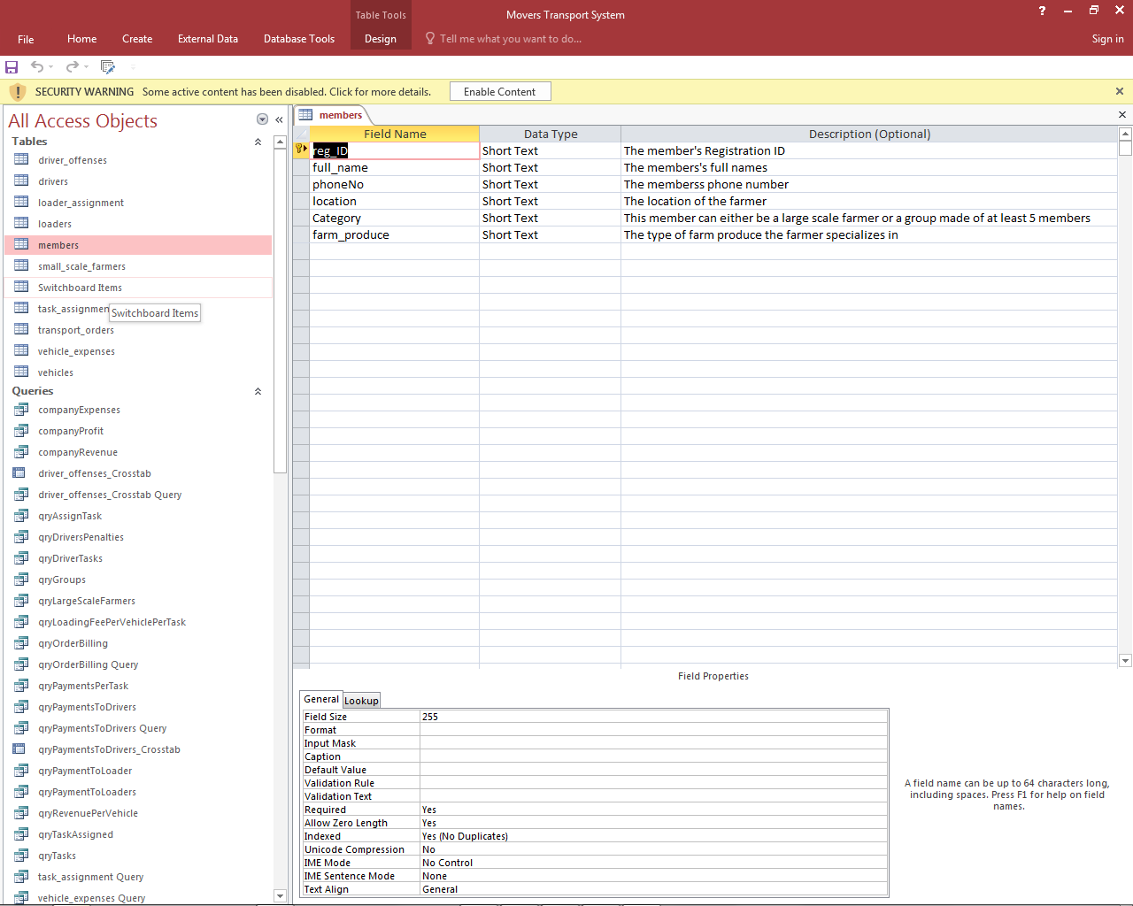

*Figure 18: Membership table*

### Small scale Farmers table

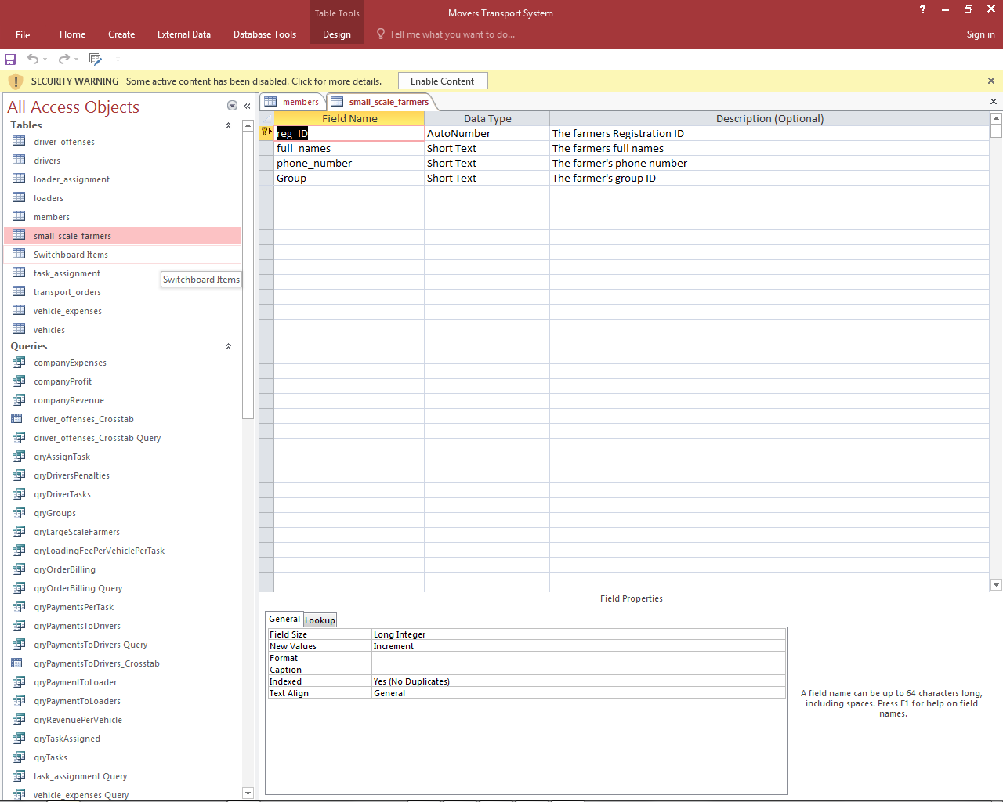

*Figure 19: Small scale farmers table*

### Transport orders table

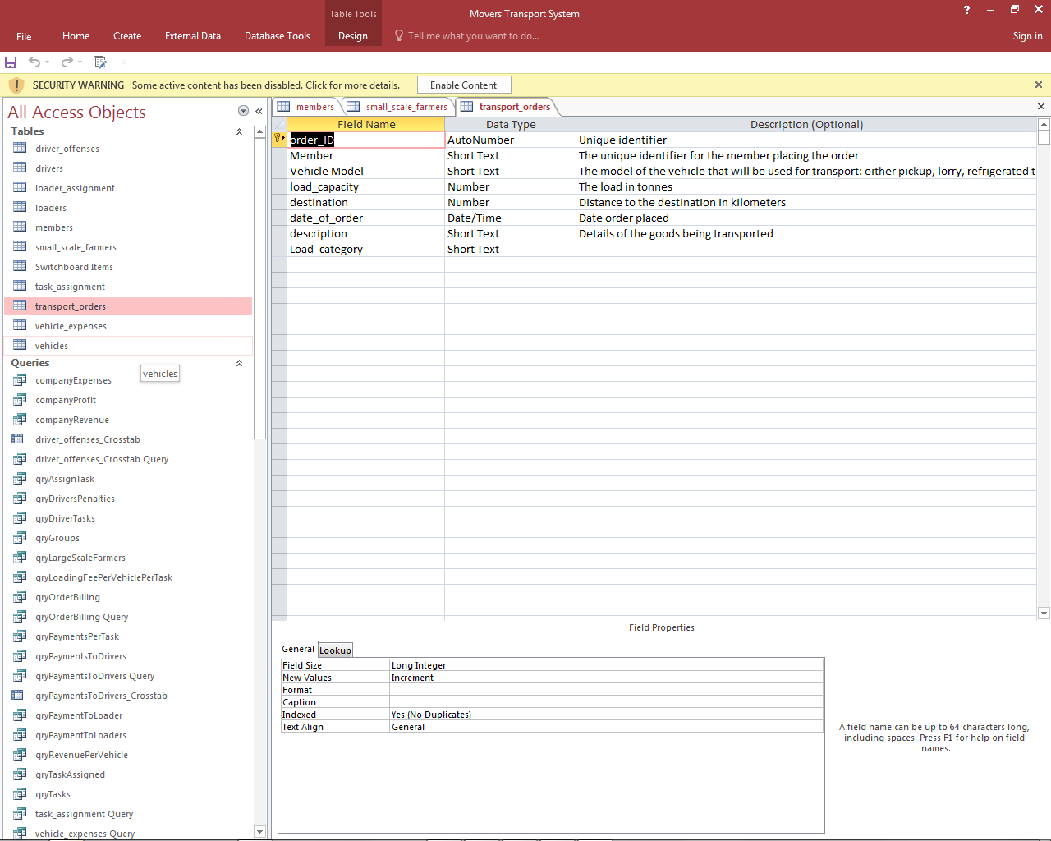

*Figure 20: Transport orders table*

### Vehicle expenses table

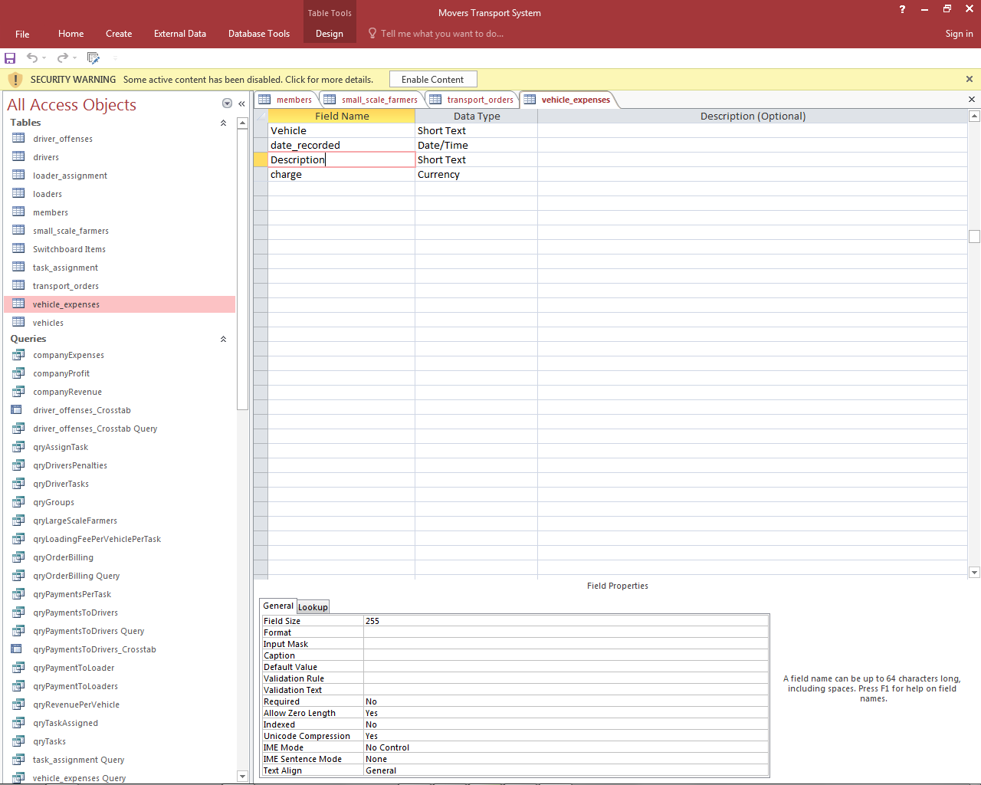

*Figure 21: Vehicle expenses table*

### Drivers table

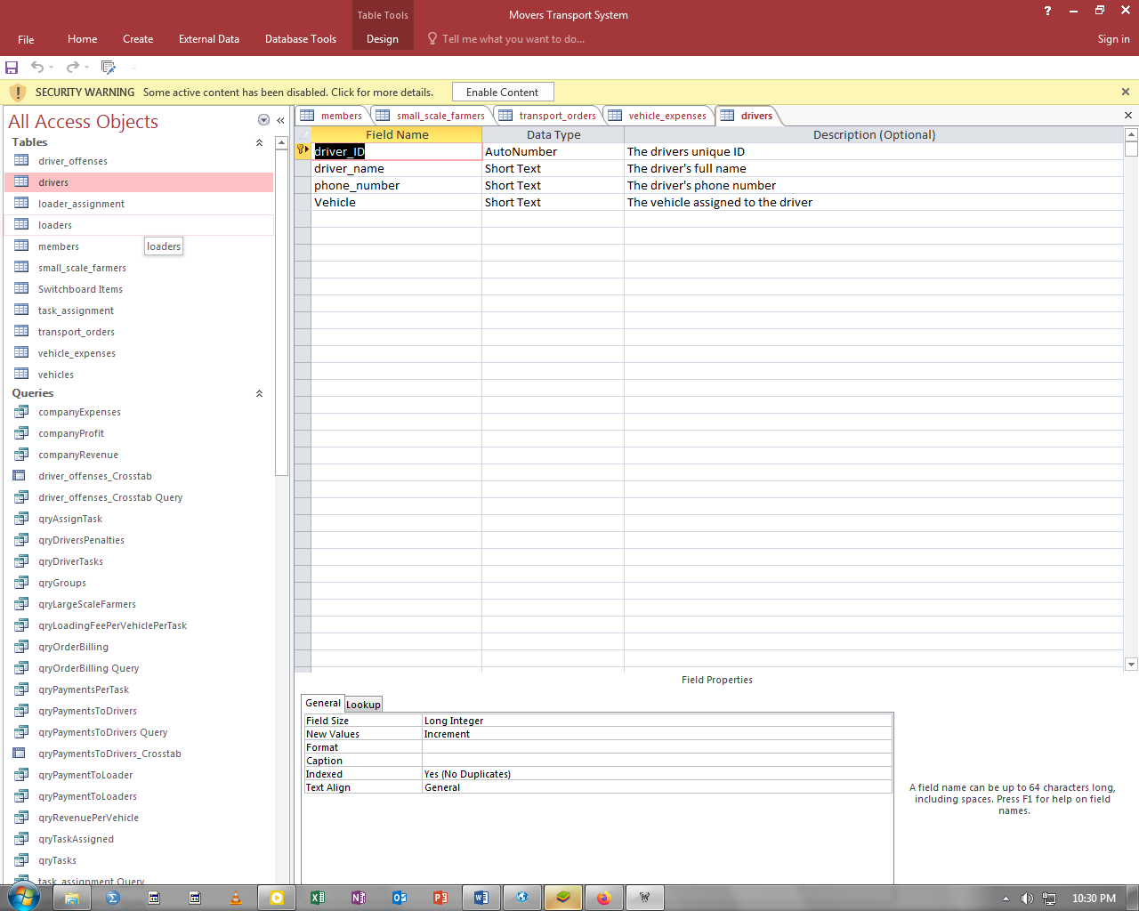

*Figure 22: Drivers table*

## Relationships

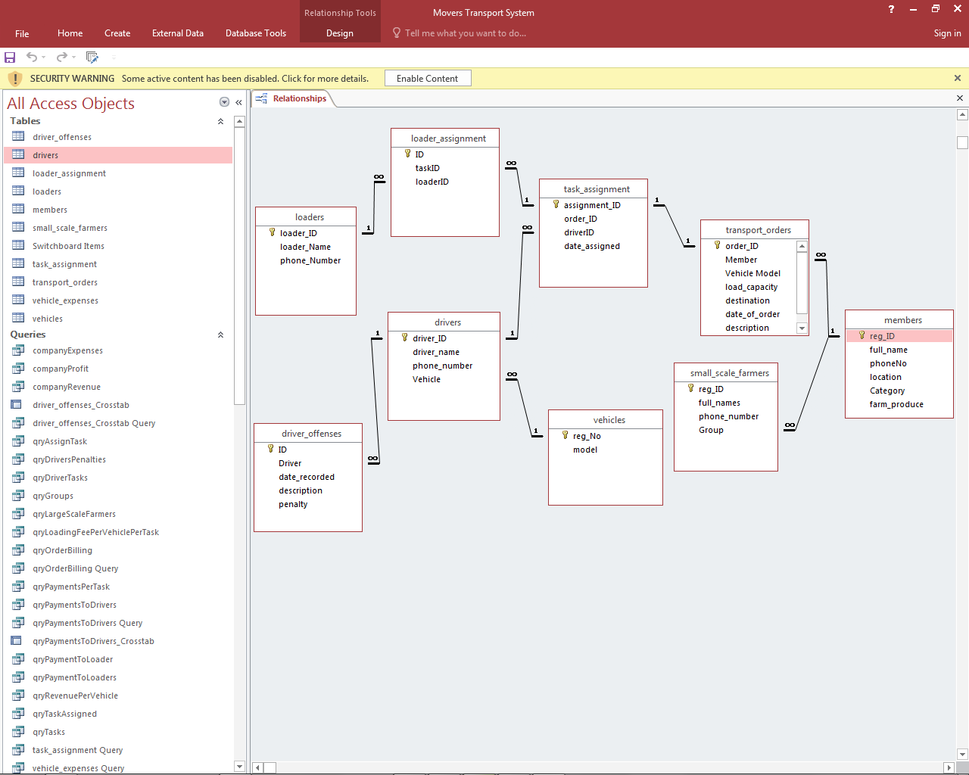

*Figure 23: Relationships*

## Input Screens

### Groups registration form

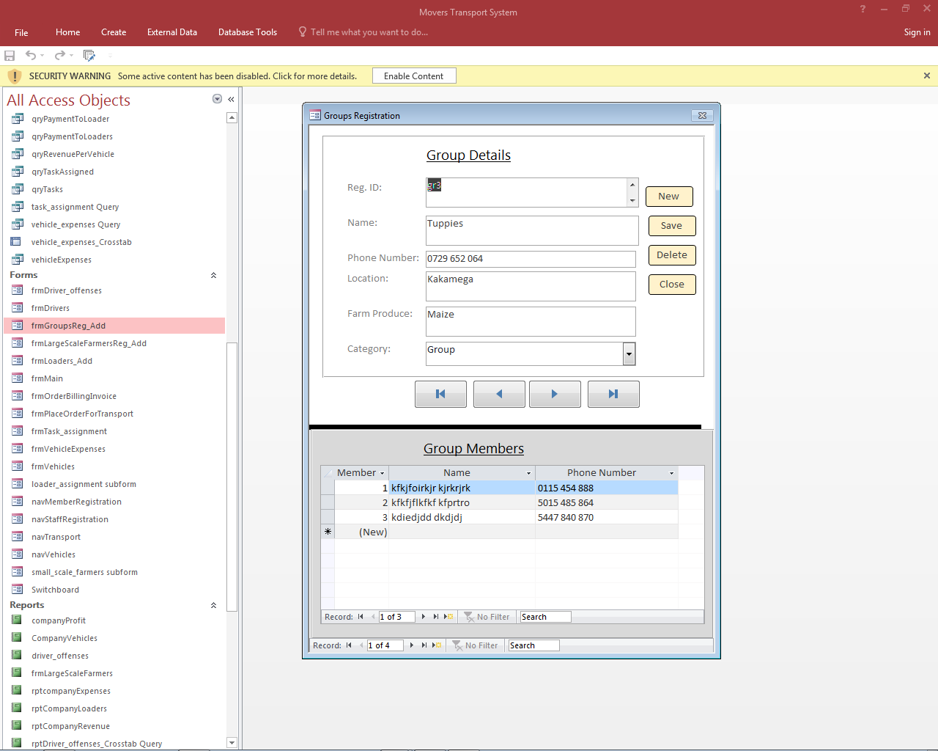

*Figure 24: Groups registration form*

### Large scale farmers’ registration form

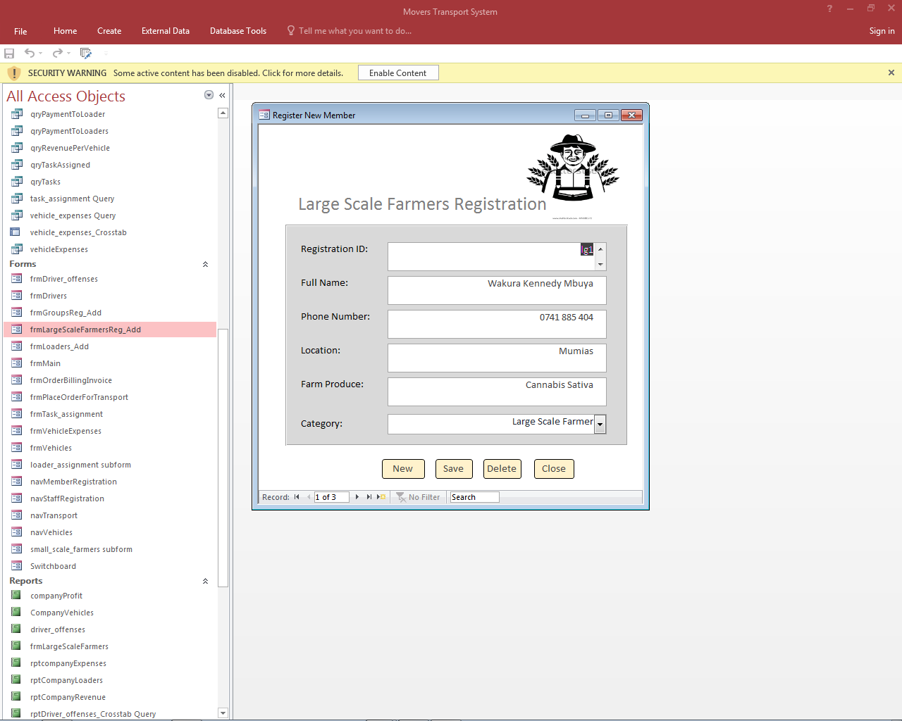

*Figure 25: Large scale farmers registration form*

### Transport order placing form

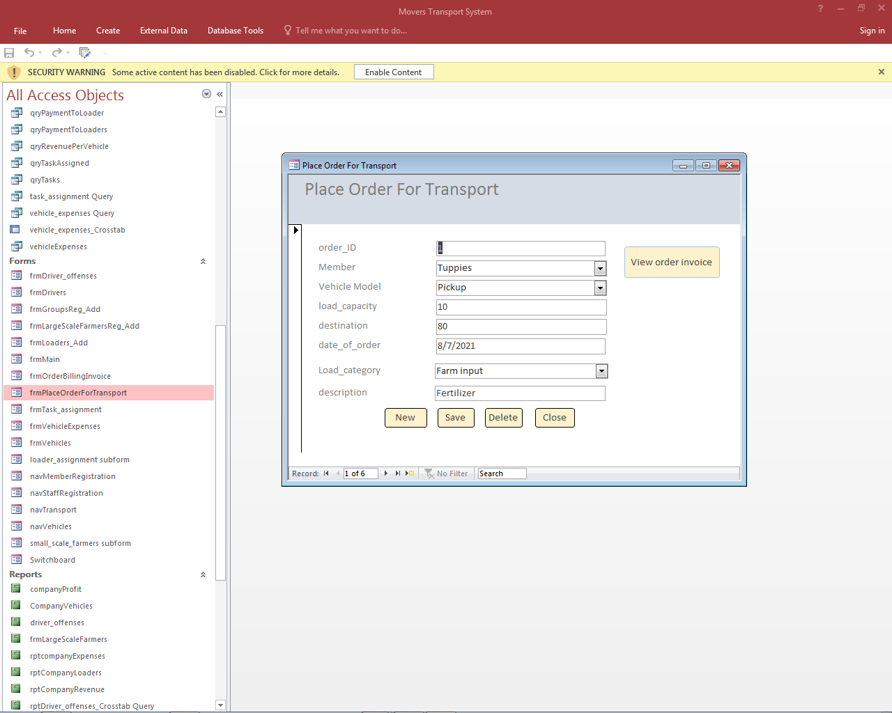

*Figure 26: Transport order placing form*

### Vehicle expenses Recording form

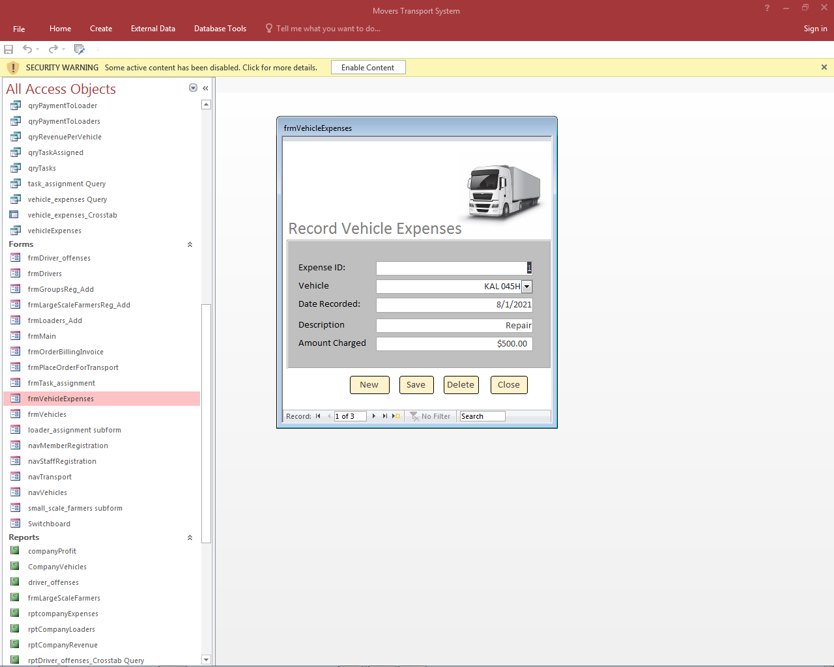

*Figure 27: Vehicle expenses recording form*

## Data Manipulations

### Payments to loaders query

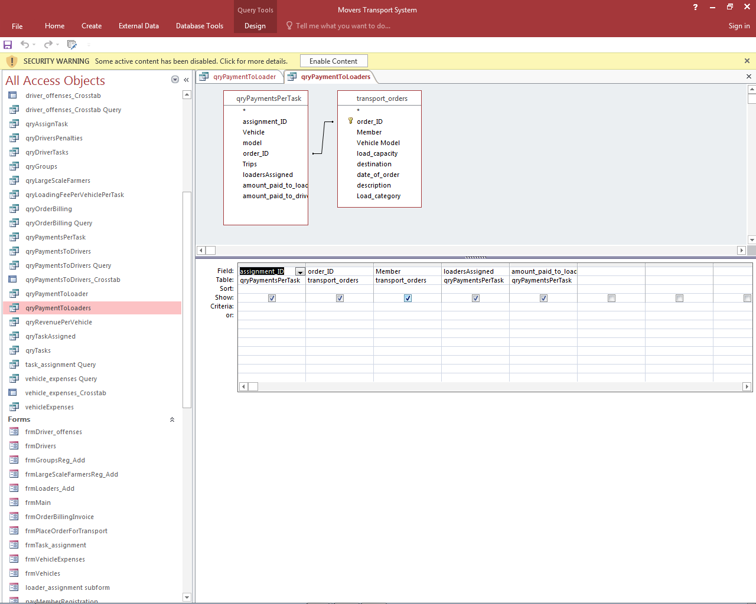

*Figure 28: Payment to loaders query design*

### Payments to drivers’ query

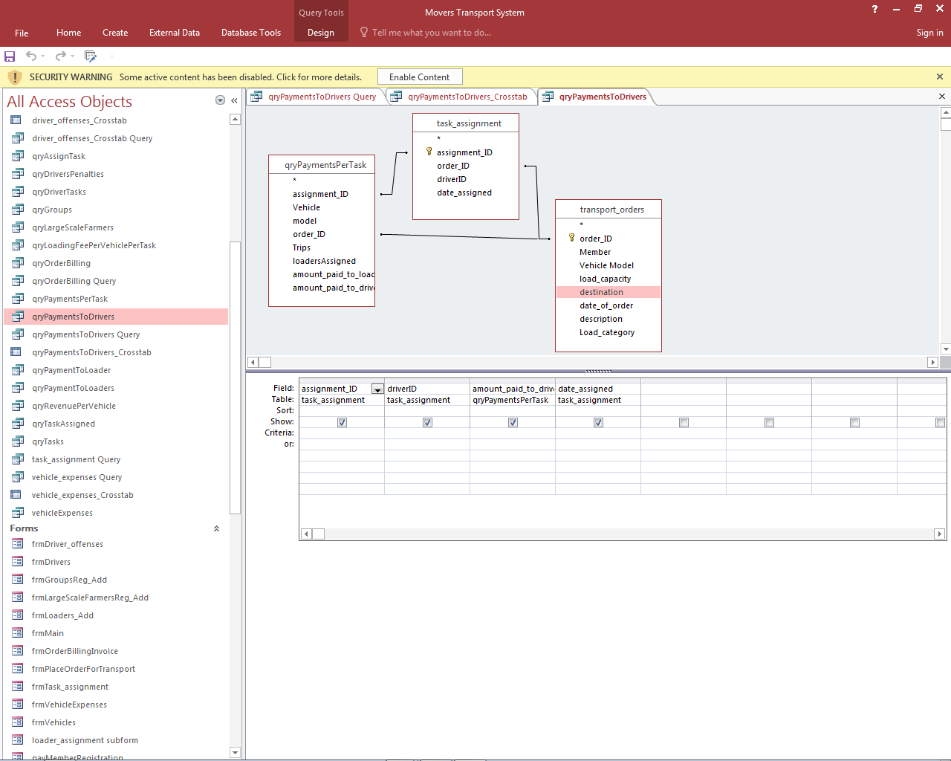

*Figure 29: Payments to drivers query design*

### Penalties surcharged on drivers’ query

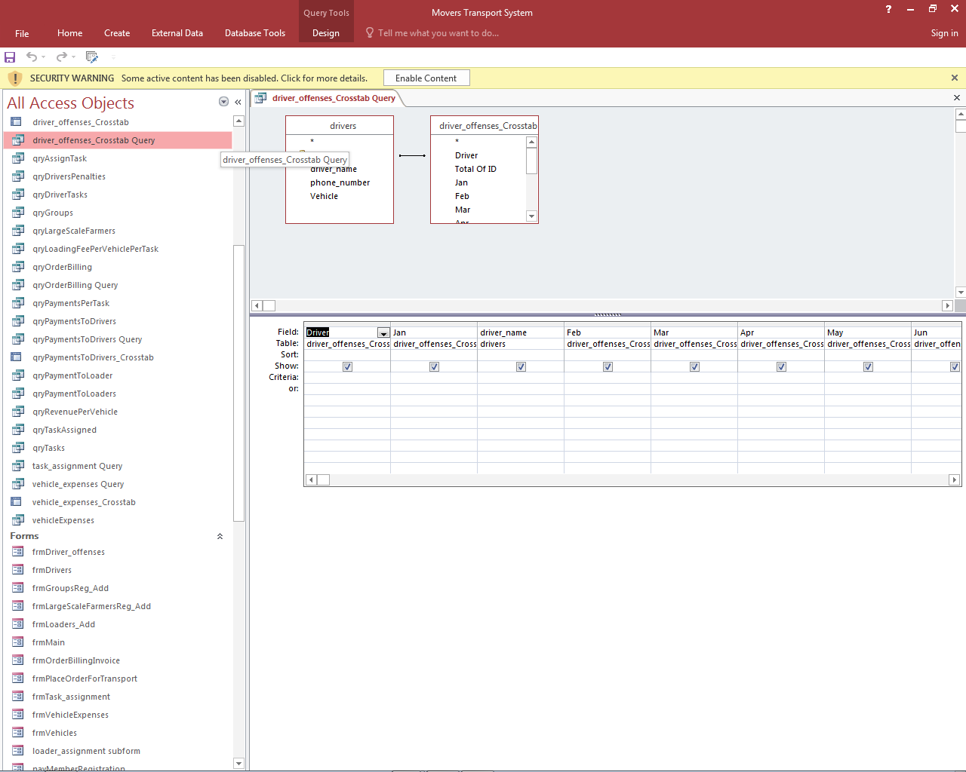

*Figure 30: Penalties on drivers query design*

### Revenue per vehicle query

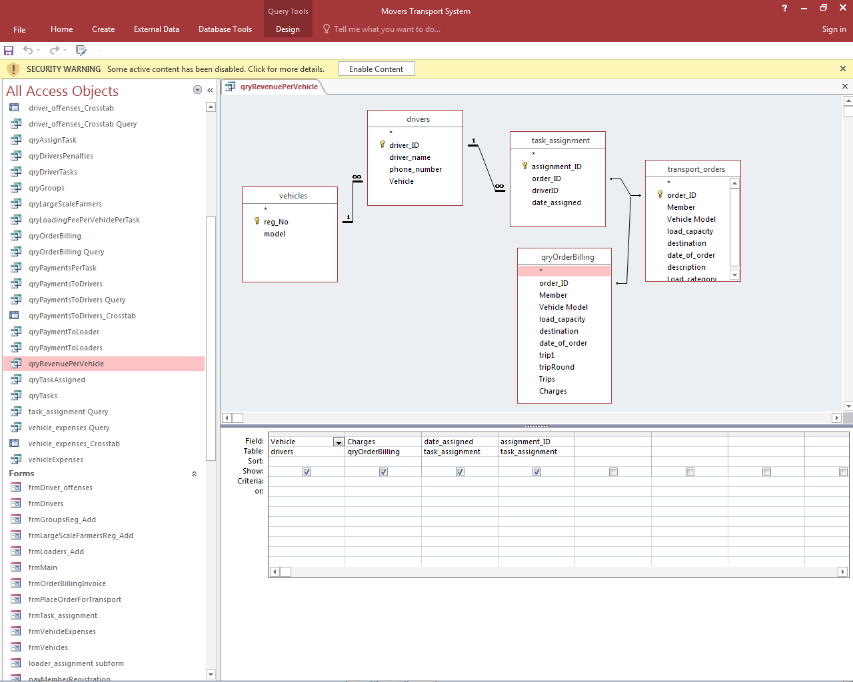

*Figure 31: Revenue per vehicle query design*

### Expenses for each vehicle

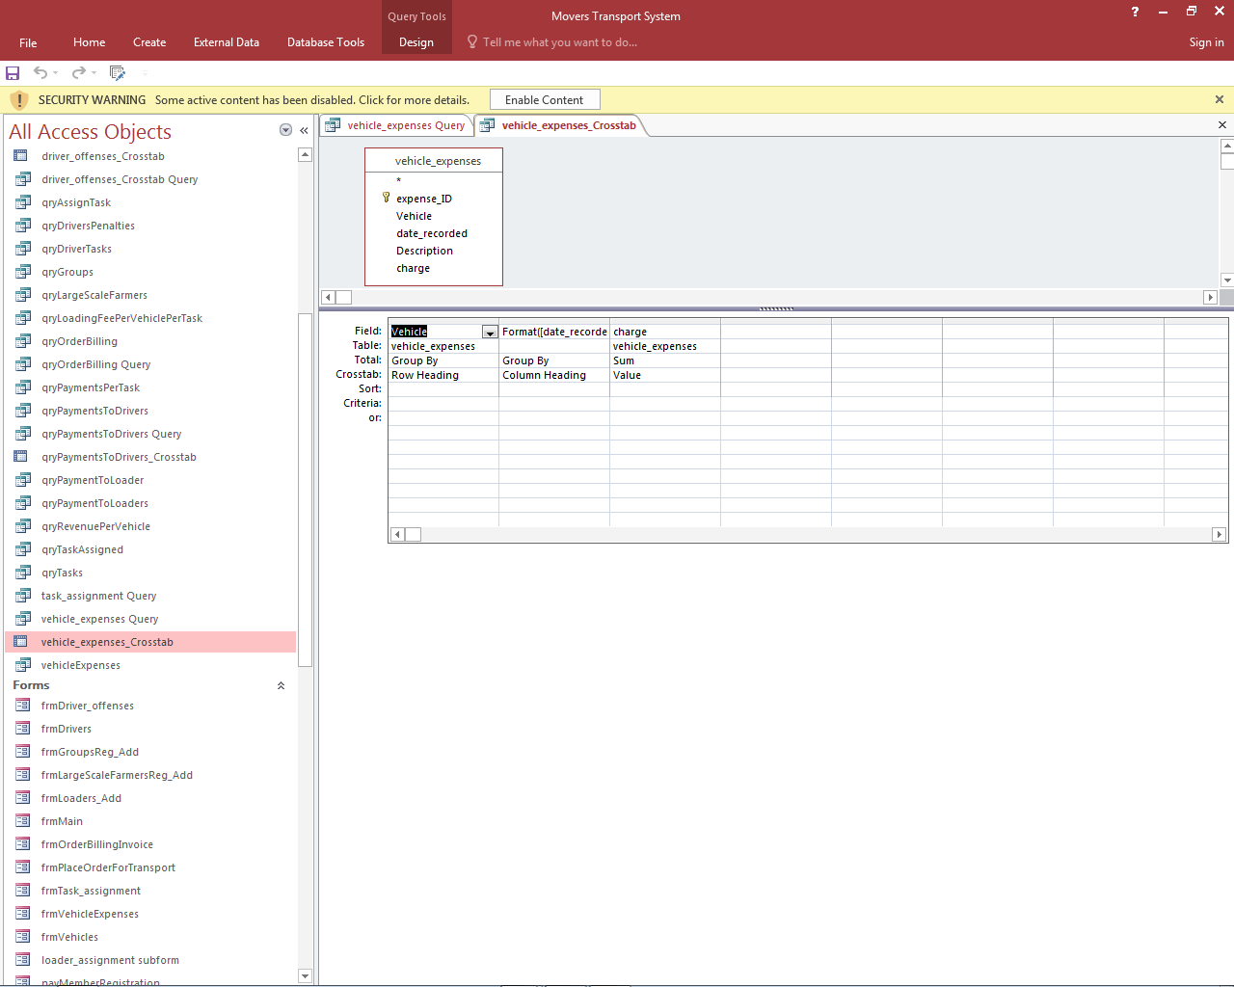

*Figure 32: Expenses for each vehicle query design*

### Tax payable

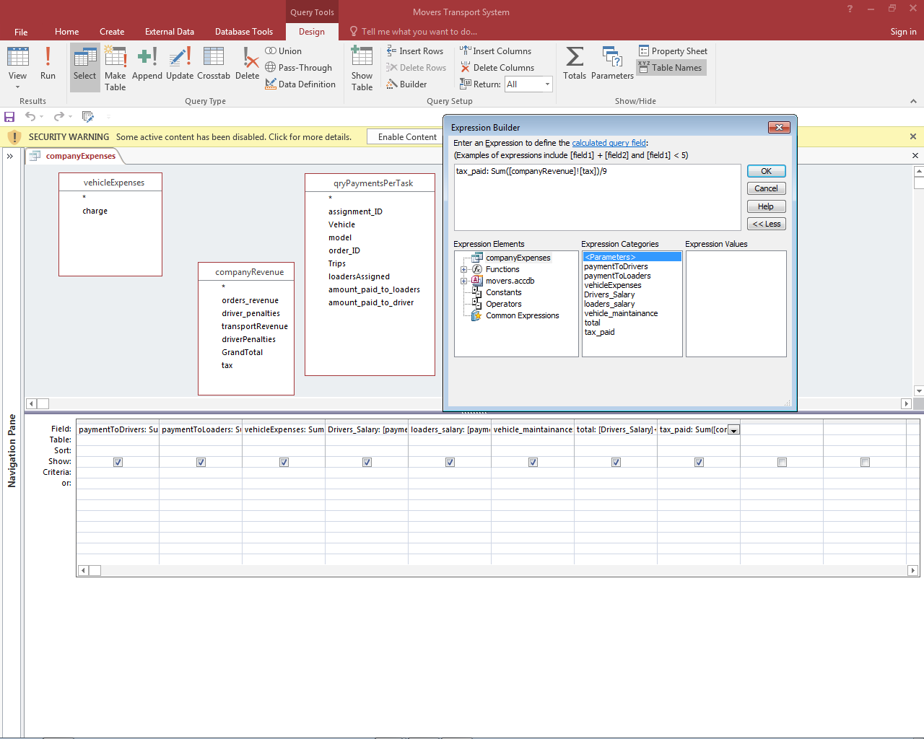

*Figure 33: Tax payable query design*

### Overall company expenses query design

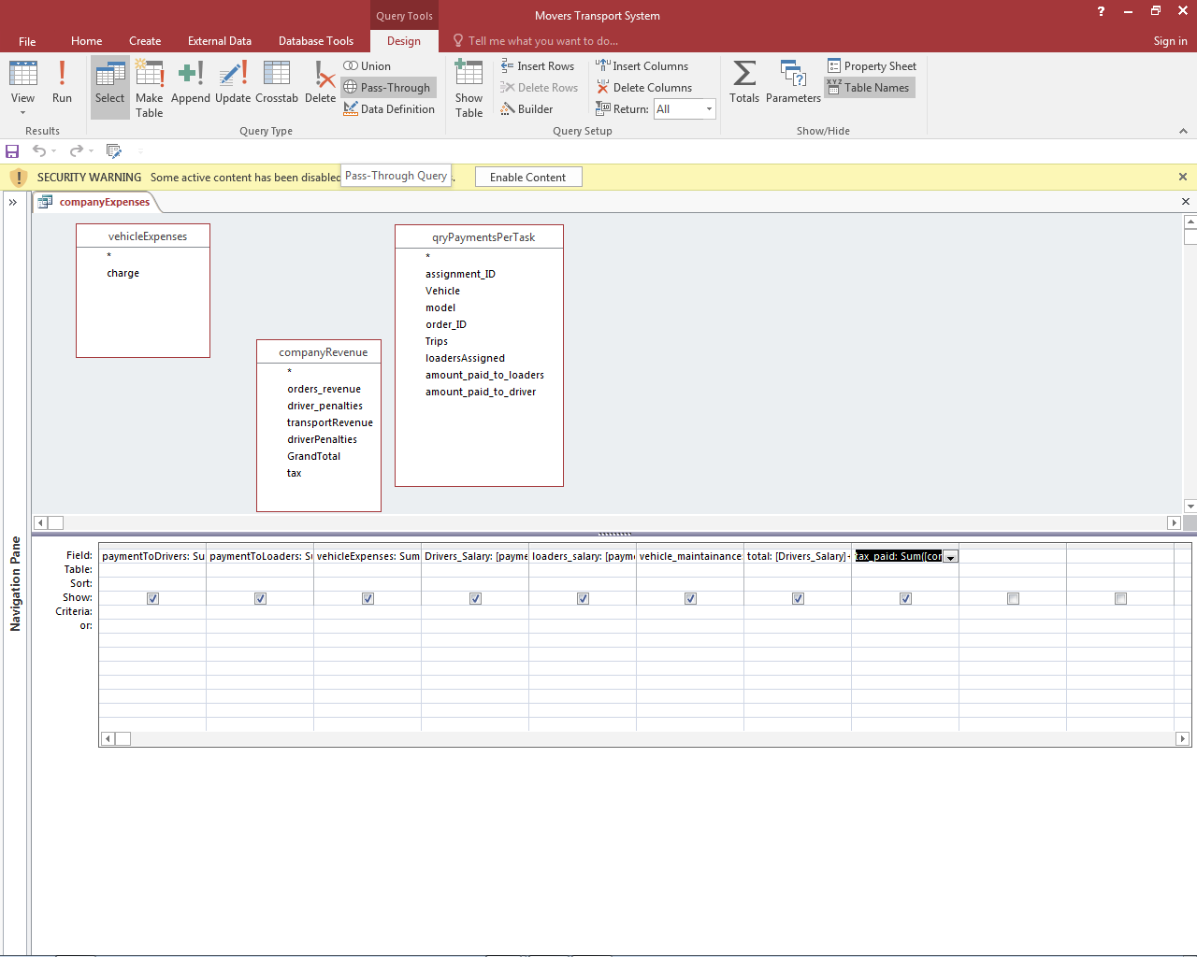

*Figure 34: Company expenses query design*

### Overall company profit calculation

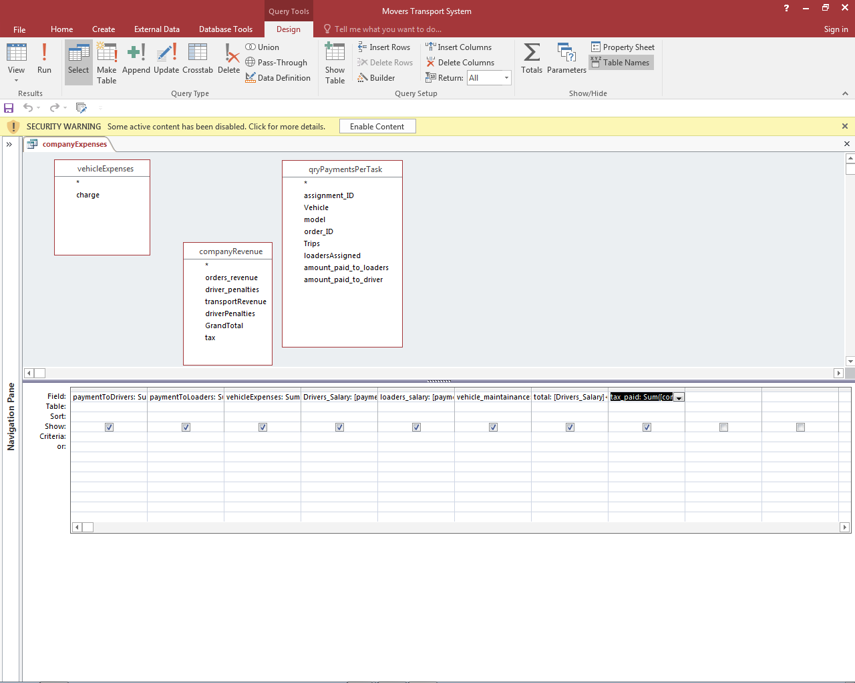

*Figure 35: Company profit query design*

## Output Screens

### Transport Order invoice report

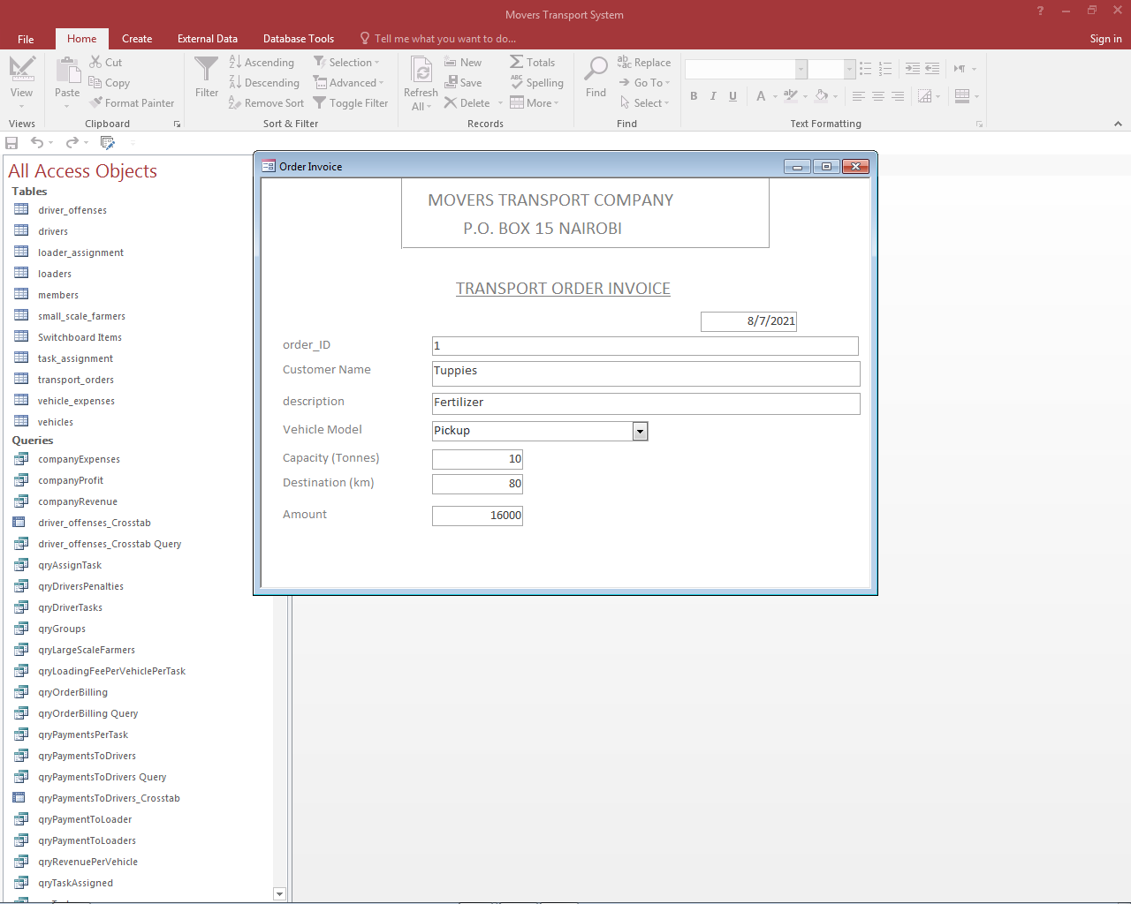

*Figure 36: Transport order invoice*

### Company Revenue Report

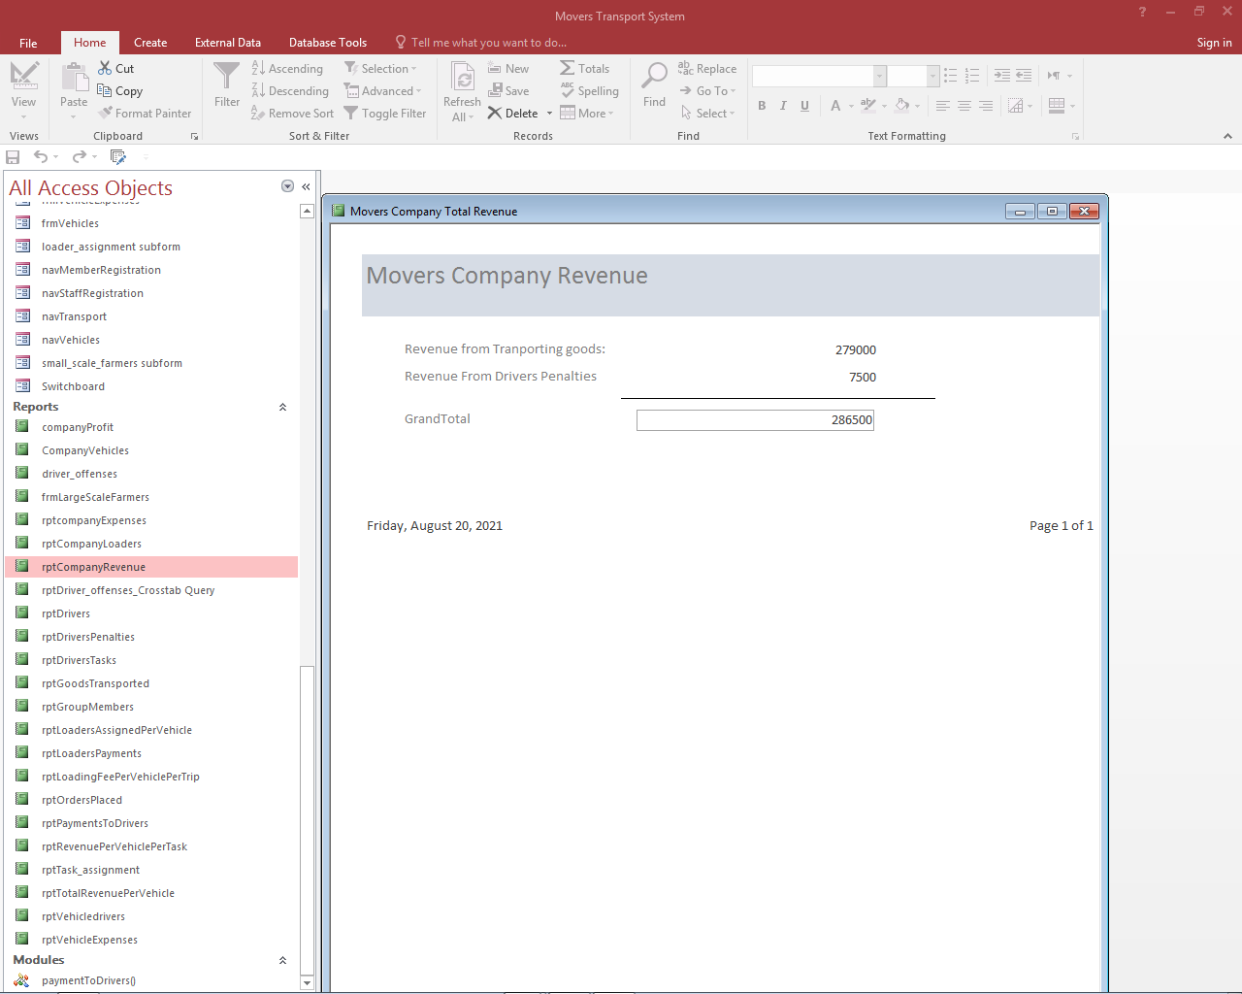

*Figure 37: Company revenue report*

1. Driver penalties report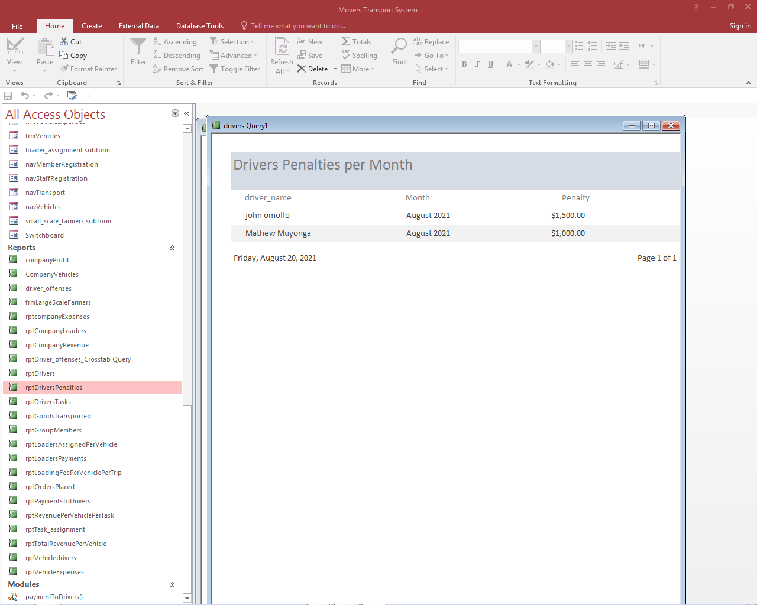

*Figure 38: Driver penalties report*

# Chapter 5: User Manual

## Introduction

This chapter introduces the user on how to install and use the system (Nekta Management System)

The following are covered in this chapter:

* How to install the system
* How to load the system
* How to navigate the system
* How to generate reports in the system

## Installing the system

Before installing this system on your computer, ensure that the computer has the following minimum system requirements:

1. The computer should be running windows 7/8/10 operating systems
2. The computer should be installed with Microsoft Office 2016 or a new version of Microsoft Office
3. The computer should have at least 2GB of RAM
4. The computer should have at least 1GB available space on the hard disk
5. The computer should be installed with an up-t-date antivirus software

Follow the following steps to install the software. This guide demonstrates installation on a computer running Windows 7 but the process is same on computer running other versions of the Windows Operating System.

1. Insert the CD loaded with the Nekta Management System into the DVD drive
2. Click on the “Start” button then click on “Computer” as shown below

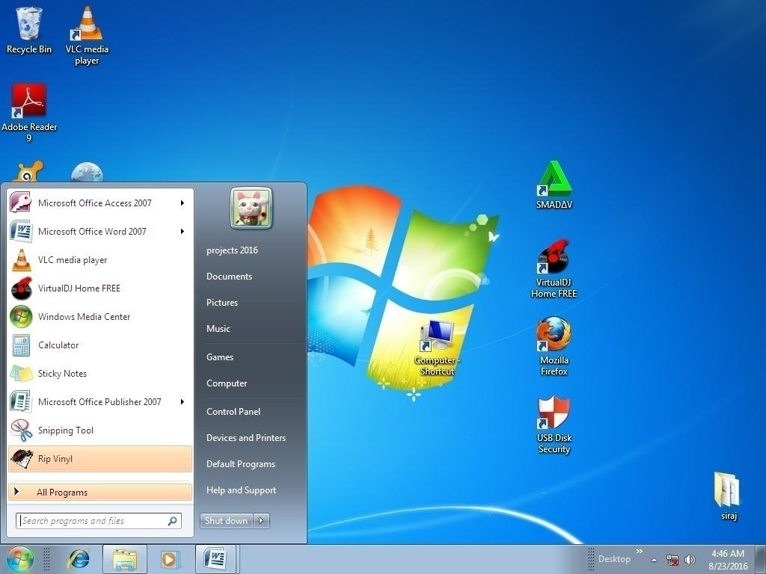

*Figure 39: Installing the system*

1. On the dialog box that appears, double click on the DVD RW Drive
2. Right click on the file named Nekta Management System then copy it to the desktop

## Loading Nekta Management System

1. On the desktop, double click on the file named Nekta Management System
2. The system will be launched and the main switchboard will be displayed as shown below:

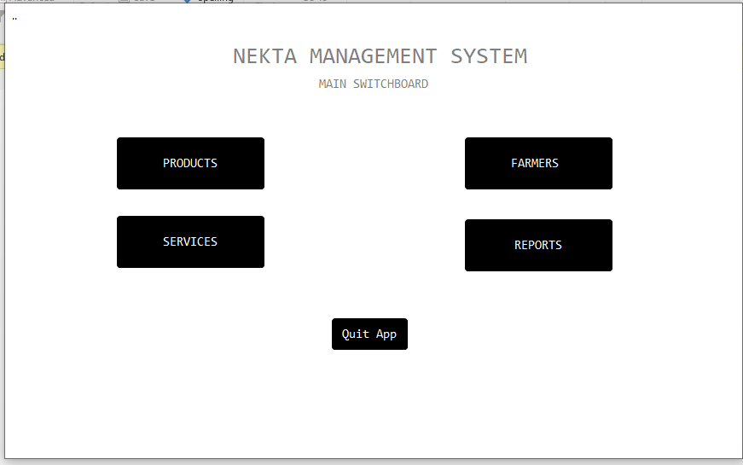

The user can now navigate the system to perform a certain activity.

## Guide on navigating through the system

The user can easily navigate through the system from the database once the system is loaded. Depending on what actions the user wants to perform, the user can select it from the main switchboard.

The main switchboard contains buttons that groups the basic operation of the system in the following groups:

1. Products – Click on this button for products management, sales and purchases
2. Farmers – Click on this option farmers information management
3. Services – Click on this option services management including transport and trainings services
4. Reports – Click on this button to generate various reports from the system

You can open any of the above option by clicking on the button from the switchboard.

## Guide on generating a report from the system

1. To generate a report from the system, proceed as follows.
2. From the main switchboard, click on Reports
3. The reports switchboard will be displayed as shown below.

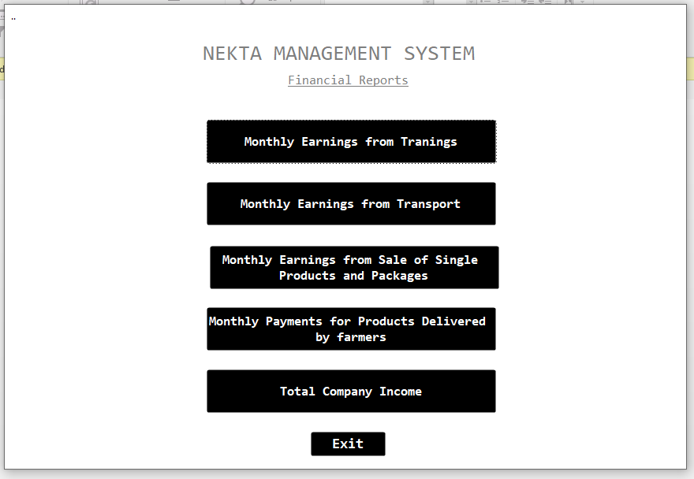

1. Select the report group you wish to generate by clicking on it from the reports switchboard.
2. For example, to generate monthly earning from training, click on Monthly Earning from Training. The monthly earning report will be generated and displayed as shown below:

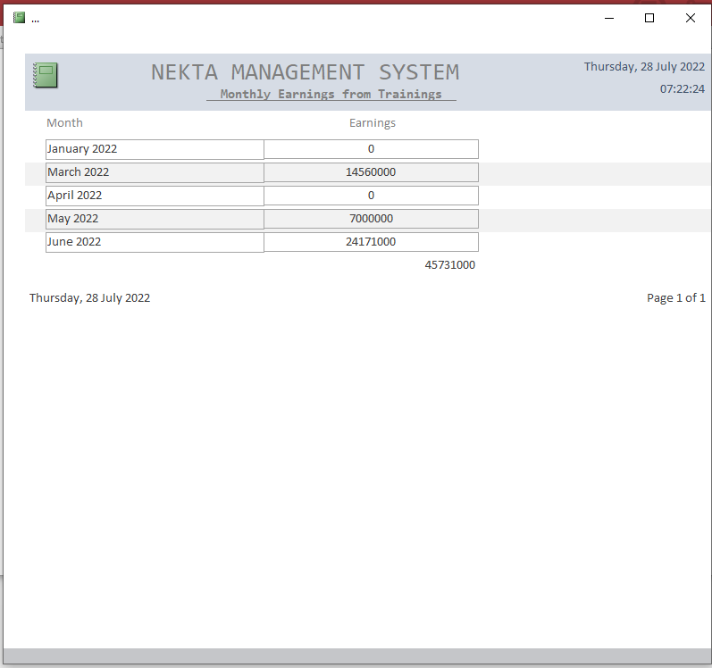

# Chapter 6: Miscellaneous

## Conclusion

The development of the Nekta Management System went well and was completed on schedule. The Nekta Management System was created specifically for the Nekta Company's needs. If fully deployed, the technology will assist Nekta Company in reducing the costs associated with their present manual system. This technology will also assist the organization in becoming more productive by assisting them in improving their operations.

## Recommendations

The system is ready for use and can be implemented immediately using phased change over strategy to minimize on the risk of failure and ensure every stakeholder is comfortable when using the system. Also, the database should be installed on a computer that has an up-to-day antivirus software installed to ensure the security of the database.

I recommend that Nekta Company to use the system effectively since it will reduce the inaccurate data processing and to maintain the system by installing antivirus software to prevent the system from the viruses. Also they should be creating backups for the updates.

## References

1. Chemwa, G. (2005). *Computer Studies.* Nairobi: Longhorn Publishers.
2. *Developing a Methodology for Observing Electronic Voting.* (2013). Atlanta: Carter.
3. Gallup. (2015). *Trust in Government*. Retrieved from trust-government.aspx.: www.gallup.com/poll/5392/trust-government.aspx.
4. Ndulo, M. (JULY 5, 2010). HARVARD ILJ ONLINE. *Free and Fair Elections, Violence and Conflict*, 15.
5. Noizat, P. (2015). Blockchain Electronic Vote. *handbook of digital Currency*, pp. 453-461. .
6. ONunga, D. J. (2005). Computer studies. In R. Shah, *Computers Studies.* Nairobi, Kenya: Mariwa Publishers Ltd.
7. S.Mburu. (2005). *Computer Studies .* Kampala: longhorn publishers.

## Appendix

Alternate process

Process

Decision

Master File

Manual input

Direction of Flow of information